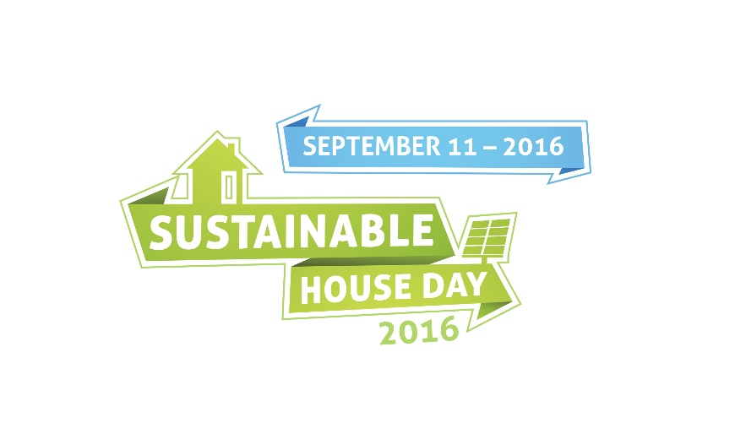

CONDITIONS OF ENTRY
As a condition of entry to this Sustainable House Day open house you agree to abide by the following conditions:
- Please officially sign in as a visitor to the home providing your full name, telephone number and email address
- Please act in a respectful manner towards the homeowner, all volunteers and other SHD attendees
- Please do NOT touch any property including furniture, objects, electrical items on the property, or personal items of others
- Please ensure children are monitored at all times onsite
- Please remain in the allocated tour area of the home. You are NOT permitted to enter any areas that have been signed as private.
- Please do NOT consume alcohol or food during the tour.
- Smoking is NOT permitted
- Please turn off/silence your mobile and refrain from answering or speaking on your phone during tours
- Please make every conceivable effort to ensure your own personal safety whilst onsite.
- Please ask permission before taking any photographs
- You agree to any inspections of bags at the request of homeowners or volunteers.
- In the garden please do not touch the plants. If you would like a cutting, please ask.

