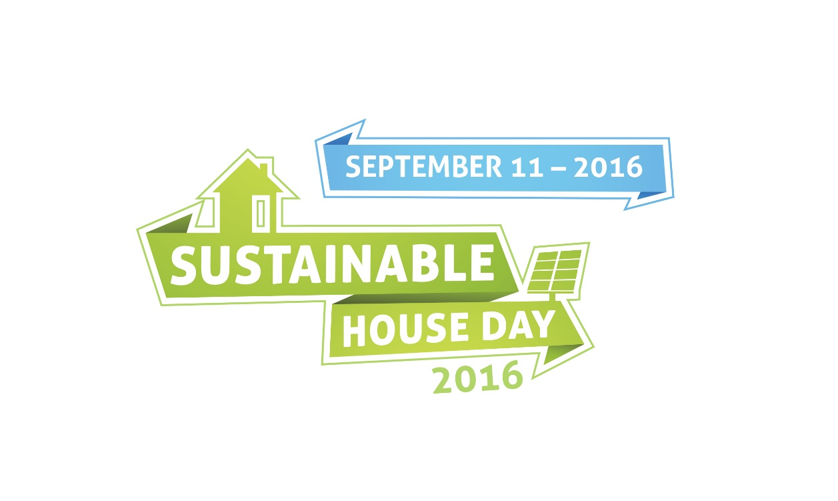

GOLD COIN DONATION
We will be asking for a gold coin donation to visit this property.

This money will Be ALLOCATED TO:
(Please insert reason ie – cover costs, charity, etc)

