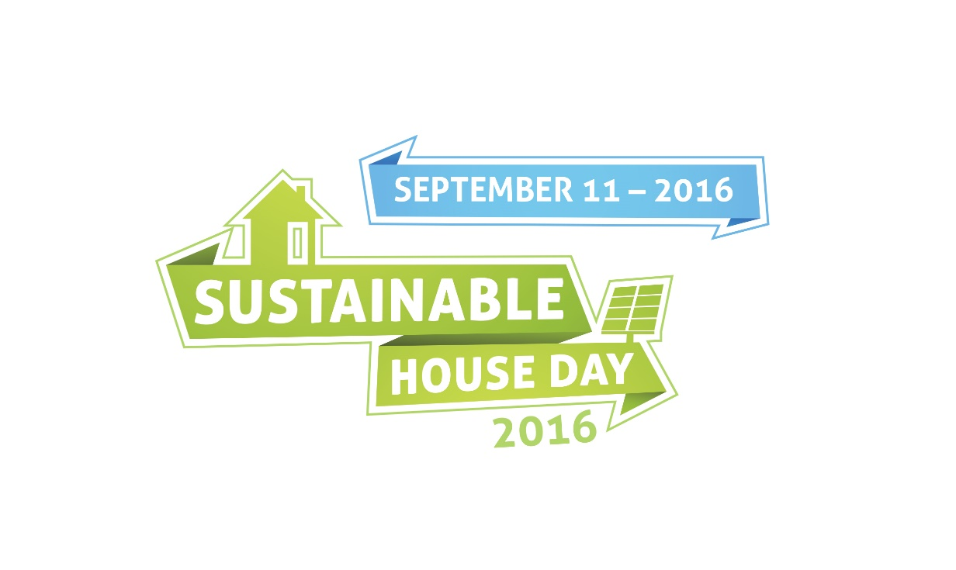

**HAZARD!  
Please be Careful**