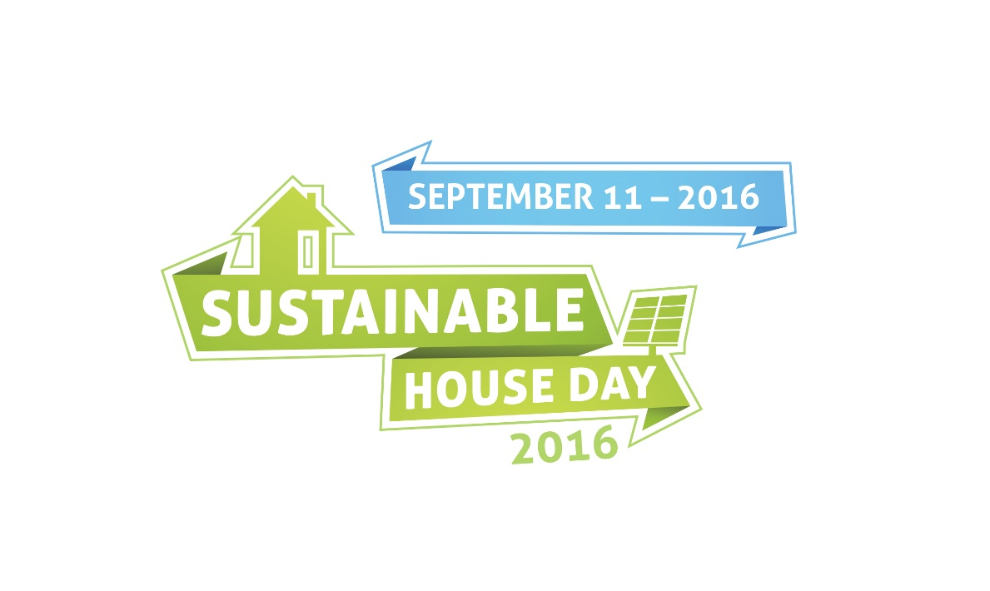

PRIVATE

NO
ENTRY

