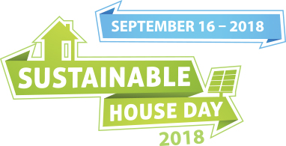

Risk Assessment Checklist

Sustainable House Day (SHD)
It is compulsory for all participating homeowners to complete this Risk Assessment Checklist and read the Risk Assessment Guidelines. Complete the following checklist prior to the opening of the property and ensure you complete any actions required.

AREA | QUESTION | YES | NO | N/A | NOTES
Entry Access | Are Entry / Exit areas clear and accessible for staff and anticipated attendees?
 | Are Entry / Exit area adequate for emergency exit and emergency services?
 | Are thoroughfares well defined and clearly marked?
 | Are pathways free of obstruction and easy to transverse?
 | Are house rules clearly displayed at entrance?
 | Are there adequate room/materials for sign in sheets for visitors (pens, clipboards, table etc.)?
Internal Rooms | Are sharp implements (e.g. knives, scissors) locked away?
 | Is any furniture broken or unsafe and need to be removed for opening?
 | Are there any personal belongings you want locked/stored away for safekeeping?
 | Is there a room you do not want the public to access?
 | Are all rooms suitably clean and hygienic for volunteers and attendees?
Hazardous Substances | Are all chemicals stored in approved containers and labeled and out of reach of general public. Keep locked away?
Alcohol | Alcohol consumption is prohibited
Floors and walkways | Are floor surfaces even? (e.g. no loose tiles or carpet that is torn or has ridges or holes)
 | Is a covering on carpets/floors required to protect against heavy foot traffic?
 | Are any floor covering used safe and free from tripping hazards, obstructions, furniture, cords etc.?
 | Do any walkways need to be signed to indicate any hazards (i.e. potential trips, slippery areas)
 | Are walkways well lit?
Stairways | Are stairways clear of obstructions, furniture, cords?
 | Are any hand rails in need of repair?
Toilets  (if made available) | Is there adequate provision of toilets and hand washing facilities for volunteers etc.
 | Will there be appropriate cleaning of toilets and washing facilities? (I.e. monitoring of wet floors etc.)
Outside | Are outside pathways as free of obstructions?
 | Are there any trip hazards (uneven steps etc.) that need to be sign posted?

