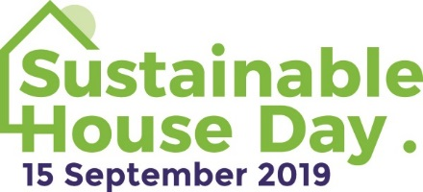

MEDIA RELEASE
May 9, 2019

Open your home and inspire others on Sustainable House Day

Have you worked hard to make your home more sustainable? Do you have knowledge to share with others about how to renovate/build sustainably and lighten your footprint on the Earth?

Submit your home to open it to the public on Sustainable House Day, to be held this year on Sunday, September 15.

Sustainable House Day is a national event that gives people a privileged view into exceptional homes designed, built or renovated with energy efficiency and environmental living in mind and allows them to speak to and learn from homeowners.

Held since 2001, the event is run by Renew, Australia’s leading not-for-profit organisation promoting sustainable living.

All homes participating in Sustainable House Day must have a minimum of four sustainability features. A sustainable feature can be anything related to sustainable lifestyles, energy saving and healthy home practices. Homes are subject to a final approval process by the event’s organising committee.

By opening your home on Sustainable House Day 2019, you can spread knowledge on sustainable technology and practices, helping and inspiring others.

To submit your home to open it on Sustainable House Day, go to: sustainablehouseday.com/submit-your-house/

Tiny living, solar with battery storage, sustainable gardens, recycled materials and innovative energy efficient design are just some of the features in homes that have opened on the day in previous years.

In 2019, about 250 houses will be open across Australia on Sustainable House Day with more than 35,000 people expected to attend.

Sustainable House Day
When: Sunday, September 15
Where: Locations across Australia
Cost of entry: Free
Details: sustainablehouseday.com

For inquiries about Sustainable House Day
Jodi Rashbrook, Renew events manager, on (03) 9631 5421

For media inquiries
Sasha Shtargot, Renew media manager, on (03) 9631 5409

