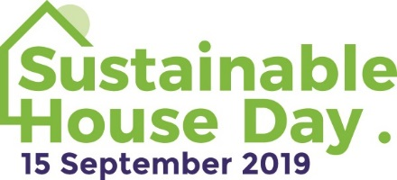

MEDIA RELEASE
May 9, 2019

Volunteer your time on Sustainable House Day

If you’d like to make a difference, helping to ensure the success of a fun event that helps the planet, consider volunteering on Sustainable House Day.

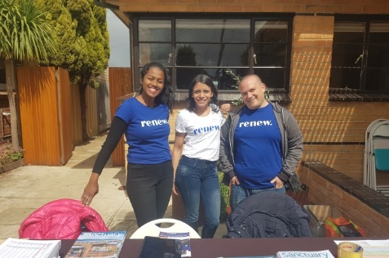
Sustainable House Day, to be held this year on Sunday, September 15, is a national event that gives people a view into exceptional homes designed, built or renovated with energy efficiency and environmental living in mind and allows them to speak to and learn from homeowners.

Held since 2001, the event is run by Renew, Australia’s leading not-for-profit organisation promoting sustainable living. In 2019, about 250 houses will be open across Australia on Sustainable House Day with more than 35,000 people expected to attend.

Volunteer roles are varied but can comprise helping to set up and pack up Sustainable House Day signage and paraphernalia in a home in your area, directing visitors through a home, creating videos or participating in the lead up to the event.

If you’d like to volunteer, fill out the volunteer form at sustainablehouseday.com/about-shd/volunteers/ and Renew will put you in contact with an organiser or homeowner participating in Sustainable House Day in your area.

Sustainable House Day
When: Sunday, September 15
Where: Locations across Australia
Cost of entry: Free
Details: sustainablehouseday.com

For inquiries about Sustainable House Day
Jodi Rashbrook, Renew events manager, on (03) 9631 5421

For media inquiries
Sasha Shtargot, Renew media manager, on (03) 9631 5409

