Preparing for Sustainable House Day (SHD)

Hello,
Thank you for your support and commitment to Sustainable House Day 2019 (SHD19).

We highly value your contribution and efforts and for being a critical part of a day designed to inspire thousands of Australians by showing them real-life, practical ways they can make their homes and gardens more sustainable.

I am pleased to provide you with these guidelines designed to assist you in SHD19. In preparing this document we are mindful that some groups/homes have been participating in SHD for a number of years and already have set procedures, whilst others have joined us for the first time. Therefore, please consider the information provided as a guide only and can be adapted to suit your local needs.

Once again thank you for participating in this initiative and we look forward to working with you to make Sustainable House Day 2019 a success.

Donna Luckman
CEO
Renew

TASK LIST
Below is a list of tasks that will help you prepare for SHD. A further description on each task can be found on the following pages of the document.

Task | Page | Completed
Review and download relevant online forms | 2
Complete your online profile | 3
Outline your event plans | 3-4
Recruit volunteers | 4-5
Local marketing and media | 5-6
Risk assessment planning and checklist MANDATORY | 6
Sponsorship materials | 6
Print off signs and all relevant sign-in sheets | 6-7
End of Day Pack up | 7
Disclaimer of Liability | 7
Insurance | 7

Review and download relevant online forms
The following forms and documents are available from the Sustainable House Day website, click here to go to the SHD website where you can download these forms. It is essential that you take the time to review and complete all of these documents.

GUIDELINES
- How to submit your house - guidelines Instructions on how to register and submit a sustainable home
- Preparing for SHD (That’s this document!)

RISK ASSESSMENT DOCUMENTS

Risk Assessment Guidelines An essential document outlining possible risks and contingency planning.

Risk Checklist Compulsory checklist to be completed for each registered property.

VOLUNTEERS
- Volunteer Guidelines Recommendations regarding volunteers for each participating household.
- Volunteer Emergency Contact Form Completed by volunteers looking for a volunteering position

MARKETING AND MEDIA
- SHD Social Media Posts and Email Template Template for social media posts and emails
- SHDPR & Media Guidelines To assist you in promoting and obtaining media coverage for your home
- Marketing and Media Meeting
- Media 101 (Climate Media Centre)

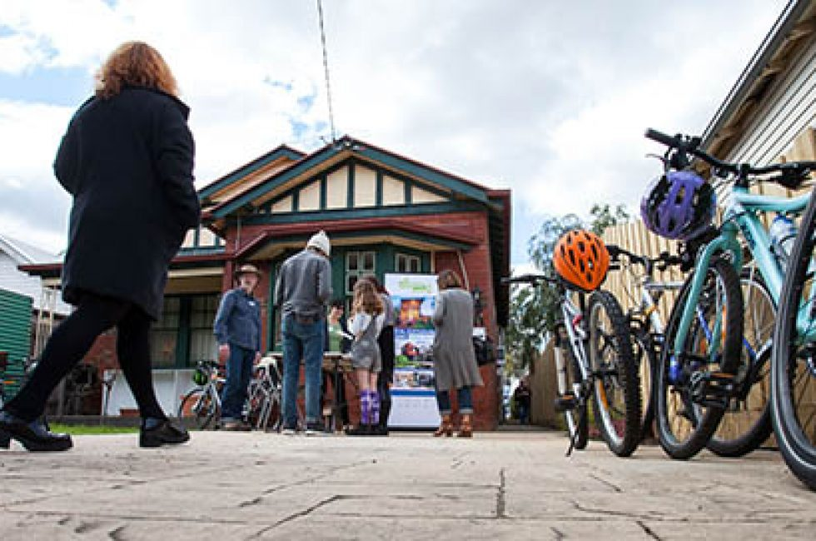
POSTERS
The following downloadable posters are available to use where required.

Official poster

Poster Do you want to live more Sustainably?

Poster Local Sustainable Home Open to you

Poster Seeking Sustainable Homes

Social Media Meme

SIGNAGE
- Sustainable Features – Blank
- Sustainable Feature- Your Home Features
- Private No Entry If you want to keep rooms or areas out of bounds for visitors
- No Parking Place these signs where they can be easily seen
- Left and Right Arrow To help direct people to your front door/entry
- Hazard If there are any areas of the home that may be dangerous to enter
- Gold Coin Donation Let people know where the donations are going to
- Conditions of Entry This must be at the entry of each house
- Photography Display at the entry and if anyone does not want to be in photos please make sure
Everyone knows and does not take photos.

SIGN IN FORMS
- Sign in Attendee Sheet Everyone who enters your home must sign in, even if they have signed in elsewhere
- Sign in Volunteer Sheet Each volunteer must sign in and out.

Complete your online profile
All homeowners are required to officially register and create their own house profile online via the SHD website. Step by step instructions can be found on the ‘How to submit your house for SHD’ form.
Once your house has been approved and published on the SHD website, we recommend you thoroughly review your profile to ensure that all the information is correct including search location allocation.

Outline your event plans
SHD HOMEOWNER TIP: This being our second year I am nowhere near as stressed and uncertain as last year. My tip, don't worry, it will work out even if you seem adrift with not enough information at the moment. - Helen

Event planning
It is now time to start planning your individual SHD event. As all homes are unique in size, sustainable features and locations there is no set formula for running an event and each entry should be tailored specifically to fit the property’s individual requirements and location. The following advice and tips are from previous participating SHD homeowners:

- Some homeowners found that tours were the best way to control the numbers and pass on information to people. Tours can be set for allotted times (ie. every half hour) or when there is a set amount of people per tour – see ‘Guidelines for organizing tours for SHD’
- Pre-prepare what you are going to say on the day and provide a copy to volunteers.
- As a number of sustainable features are ‘invisible’ place signs at each sustainable feature (e.g. cards with large font) explaining items further (i.e. low VOC paint, flexible shading, etc)
- Create a one-way pathway for people to travel through your home with the entry and exit doors separate if possible.
- Have someone located at technical stations/sustainable features to provide some further details or answer questions
- Create a handout sheet/map explaining the sustainable features around the house in detail for people to take a self-guided tour throughout your home.
- Have notice boards or a table with handouts/notices for people to review and select as they choose. Ensure the notice boards/tables are placed within an area that allows for people to freely move around and does not cause congestion
- Allow people to do self-guided tours through the gardens with a map suggested for those with larger properties
- Suggested information for display may be of interest: utility bills, novel technologies, performance statistics, an overview of changes/products
- Have copies of your energy/water bills for people to see, visitors are always interested in money savings.

For further assistance please join the SHD Homeowners Facebook Page to request advice and tips or directly contact shd@renew.org.au.
SHD HOMEOWNER TIP: I did half hourly tours last year and still lost my voice by end of the day. I only had 150 visitors. I also had 3 x notice boards of building envelope info/utility bills/ novel technologies and some performance stats. These were set up in the carport out of the weather. (ie 3 of 1200mm x 3600mm boards with about 25 A4 pages on each board) this reduced a lot of the questions from previous years. I am hoping to talk less this year, i.e only respond to specific questions and not give a precise of the project each tour. - Alan

SHD HOMEOWNER TIP: We've set up little laminated cards around the house explaining each feature - big font, only a couple of sentences, stuck up with blu-tac - then let people wander through at their own pace. Some ask us extra questions, some don't. Had 115 people last year, and it worked well - Ella

SHD HOMEOWNER TIP: Our homeowners have found that tours are a better way to control the numbers and pass on information to people. Often the eco features are not visible and need to be described. Alternatively you would need to put signs up so people can recognise them eg. low VOC pain, flexible shading etc. Outside it may be more appropriate to let people wander. If the property is large then a walking map is beneficial. - Vicki

Recruit volunteers
Once you have confirmed how your specific SHD open house/event will run, you can now ascertain how many volunteers you need during the day and any assistance you may need prior to the event.

- Make a list of tasks: Once you have an outline of how the day will be run on, next write down the tasks that will be needed to be completed and what you would like help with in the lead up to and on the day.
- Make a list of volunteer roles: Your task list will outline how many volunteers you require and for what roles. We recommend for each house participating in SHD you would typically require a minimum of four people/volunteers onsite to manage throughout the day. You will need to assess this recommendation dependent on the size of your property and the location of your sustainable features and plans for the day.
- Recruit your volunteers: Suggested people to approach for volunteers includes local environment community groups or council, friends, family, neighbours, local students, relevant suppliers. You can always send a message out via your social networks (email, facebook, twitter, telephone etc). Renew will be recruiting volunteers, contact us if you require additional assistance on the day..
- Assign your volunteers to appropriate roles: Once you have recruited your volunteers ensure that you assign them to appropriate tasks for their age, experience and abilities.
SHD HOMEOWNER TIP: Recruit friends familiar with your property; reps from companies which installed sustainable features at your place (they could stay just for 1-2 hours or only do a talk about the feature at designated time); local council sustainability officers (need to show them your property beforehand); your local gardening club or permaculture group members. Clearly discuss with each volunteer what is expected of them, give them tasks they are able to perform. Make sure they have supporting materials. There are small things which add to the experience, such as offering food and drinks (do not discount the humble tea lady!). Get your kids to bake something, make preserved food and sell them. - Margaret

RECOMMENDATION: We also recommend that you have a prior briefing with your volunteers providing information on relevant sustainable features of the home. Also if you would like to meet other home owners prior to SHD please email me on shd@renew.org.au and I will contact the other homeowners for you.

Local marketing and media
Once again, all participants are asked to assist on a local level with marketing and media for your individual event for Sustainable House Day. A PR and media guidelines document has been posted on the website for all to review, however following is a brief outline of this document.

Check your website entry
Once your house has been approved by the SHD national organisers please check the website in the weeks prior to SHD to ensure these details have been made public and all information listed is correct.

Simple marketing tips
Here are a few things you can do to help promote your house and to help spread the word and create a buzz to make SHD a great event for everyone:

- Email: personalise an email to all your contact lists: your local sustainability or gardening groups, your kids' school, your co-workers, friends, neighbours, family to let them know about your open house. Here is some generic text you can use:

Are you thinking about remodelling or building your home and looking for inspiration? Do you have questions for homeowners or architects about their selection of sustainable materials?

Are you curious to see what it takes to create a beautiful low water garden or energy efficient home?

Nearly 150 fabulous green homes will be open across Australia, allowing you to see a diversity of new builds and renovations, learn from the architects/designers and homeowners themselves. To see homes on the day, you must register online at sustainablehouseday.com.

Want to save money whilst living in a light filled, healthy home?

- Facebook: start by liking Sustainable House Day, share a post or create your own of your house, encouraging your friends to register to attend SHD. Tag using #SustainableHD

- Twitter: Follow us @sustainableHD and tag us in using #SustainableHD as you promote your house and encourage followers to register.

- Instagram: Follow us on sustainablehouseday and make sure you use the tags #SustainableHD

- Local Media: contact your local media (newspapers and radio) advising them of your involvement in SHD (They always love a local story!). You can use this template media release (edit the highlighted yellow areas) and here are some helpful media guidelines to assist you. It is a good idea to start making contact now, as there is often a long lead time for local media outlets.

- Posters: create a buzz in your neighbourhood by downloading posters that you can personalise, print and distribute before the event at work, local shops, cafes and community centres etc.

Don’t forget to notify us of any publicity you have received so that we can promote it on our social media platforms and website. It’s also helpful for us to know who the reporter and newspaper/blog was so that we can contact them next year.

Risk assessment planning and checklist
Homeowners and local groups are responsible for ensuring they are able to minimise any risks to any attending individuals and property for the duration of their SHD event. It is compulsory for all participating homeowners to undertake a thorough risk assessment and implement necessary changes to ensure that their home is safe for opening to the general public.

A Risk Assessment planning document and checklist is available for download from the Sustainable House Day website http://sustainablehouseday.com/about-shd/forms/ for you to review and complete. We recommend that you read this thoroughly prior to your event and complete the risk assessment check list. It is also a good idea for you to continue to monitor safety throughout the duration of your event to ensure safety levels are maintained.
SHD HOMEOWNER TIP: Put signs where there is a danger of tripping (stairs, decks etc) or mark the edges with a bright coloured tape. Direct people traffic so there will be no congestion on stairs or narrow passages. Remove all loose items lying on the ground. Put potted nettles where you don't want people to go. - Margaret

Sponsorship materials
Based on feedback from previous years, we will not be sending out any sponsor or event materials to individual homeowners for distribution or display.

Print off signs and all relevant sign-in sheets
It is recommended for all volunteers and attendees to officially sign upon entry to your home. This is recommended so you can maintain a record of all people who are onsite for OHS purposes. There are official sign-in sheets available via the website. http://sustainablehouseday.com/about-shd/forms/

Print off and place signage
A variety of signage is available for download from the Sustainable House Day website, this includes conditions of entry, directional, parking and a sign you can fill in with details of sustainable features. Signage placement tips include:
If visitors aren’t likely to be able to pinpoint the house in the Street Directory, then put up one or more signs along the main approach roads.
- Put yourself in the visitor's position and assume you don't know the area - where would you expect to find a sign?
- SHD signs should be hung on the front fence, or somewhere prominent, to catch a visitor’s eye as they drive along the street. If it's not obvious to visitors where to enter when they've found your house, put up an arrow or two.
- If you are opening in alternative hours to the 10am to 4pm that is being advertised, we recommend that you provide notification of this on your signs.

End of Day Pack Up
At the conclusion of the event you should:
- Inspect the home once all of the visitors have left and ensure there is no damage or missing items. If anything has occurred, please complete an incident report form and return to the ATA. This will assist us in creating risk assessment plans for the future.
- Collect your sign in sheets and tally up the number of visitors. Please email numbers and scanned copy of forms to shd@renew.org.au. or alternatively post to:
Sustainable House Day,
Renew | Level 1, 39 Little Collins Street,
Melbourne VIC 3000.

It is critical that we receive these tallies and sign-in sheets ASAP.

Put your feet up and pat yourself on the back for a job well done in promoting sustainable lifestyles
Disclaimer of Liability
Sustainable House Day organiser Renew:
- has the right, without consultation, to cancel or alter components of Sustainable House Day in part or entirety
- will assume no liability resulting from partial or complete cancellation of the event for any reason
- requires all SHD homeowners and groups to have insurance as per the terms and conditions
- does not endorse specific renewable energy or energy efficiency products or systems presented during the Sustainable House Day and assumes no liability for performance or related issues of said components or systems
- will not be held liable for any losses, damages, claims, costs or expenses relating to physical property, or personal injury or death, that may occur and visitors assume full responsibility for their behavior or actions

Insurance

Please note, all homes and groups opening for Sustainable House Day, must provide a copy or the name and policy number of their current Home or Public Liability Insurance policy.
It is important for home-owners to understand that if an incident or accident occurs the home owner will need to produce a policy that may be called upon to respond. Should an action arise, it will be determined by the Courts whose policy will respond at the end of the day.
It is therefore mandatory that all open homes carry a current home insurance policy.
All participating coordinating groups will only be involved if they hold a current policy for Pubic Liability Insurance and Volunteer Insurance.
To assist with minimizing the exposure of risks attached to the event. A risk plan will be developed for the event on forwarded to all local sustainability groups.

