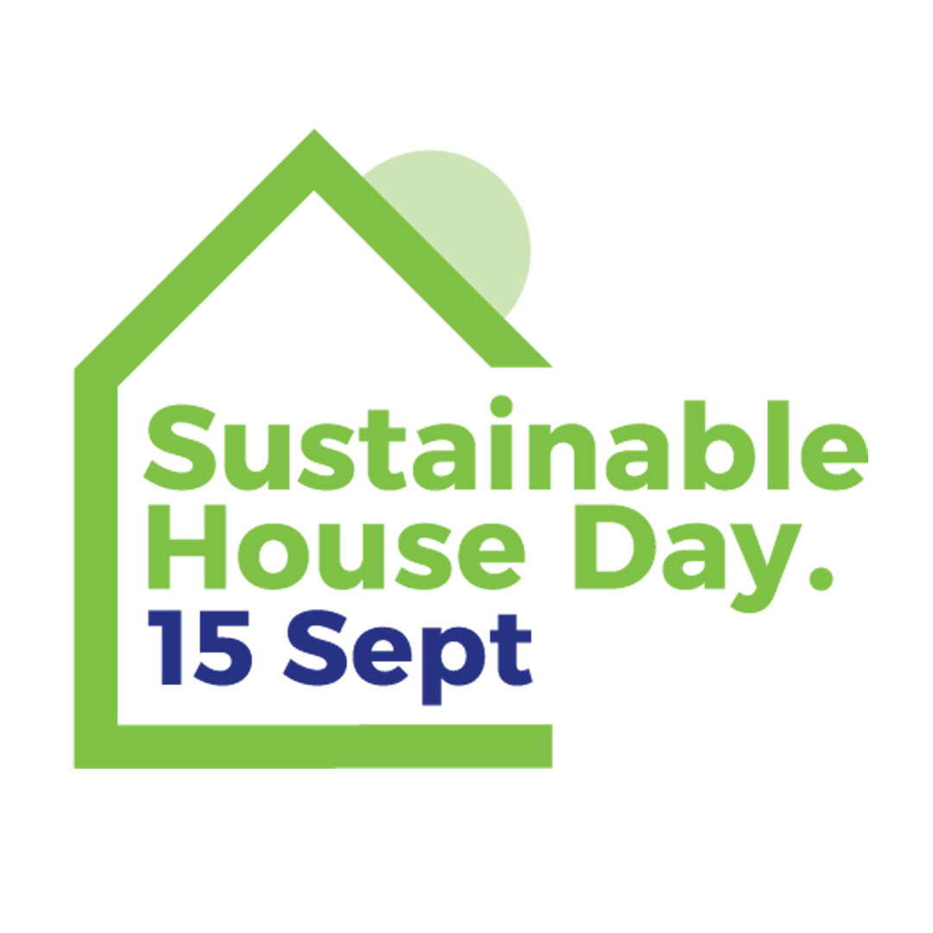

**Open House**

**10am – 4pm**