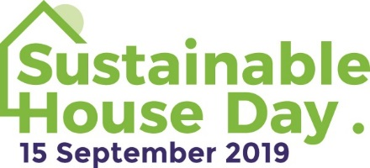

MEDIA RELEASE
July 9, 2019

Inspiring homes to open their doors on Sustainable House Day

Australia’s best homes designed for comfort and low bills will be open to the public on Sustainable House Day, taking place on Sunday, September 15.
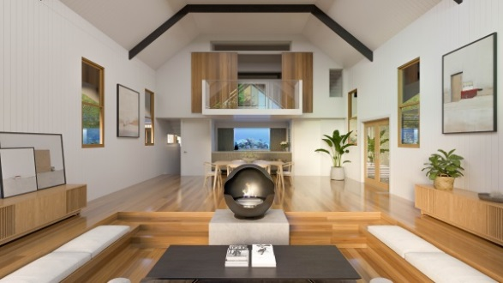
The national event will give people a rare view into exceptional homes designed, built or renovated with energy efficiency and environmental living in mind and allow them to speak to and learn from homeowners.

Houses made of hemp, electric vehicles, tiny living, solar with battery storage, sustainable gardens, recycled materials and innovative energy-efficient design are just some of the features people are likely to see on the day.

In 2019, about 250 houses will be open across Australia on Sustainable House Day with more than 35,000 people expected to attend.
Held annually since 2001, the event is run by Renew (formerly the Alternative Technology Association), a not-for-profit organisation that promotes sustainable living.
“Sustainable House Day is a great opportunity to come and learn how to make your own home more comfortable, more liveable and cheaper to run,” says Donna Luckman, CEO of Renew.

“A home that works – that’s well-designed, healthy and runs efficiently in an age of high energy costs – is what everyone wants. That’s what people will see on Sustainable House Day this year.”
To view the profiles of this year’s homes opening on Sustainable House Day and to register to attend, visit sustainablehouseday.com

Sustainable House Day
When: Sunday, September 15
Where: Locations across Australia
Cost of entry: Free
Details: sustainablehouseday.com

For comment
Donna Luckman, Renew CEO, on 0432 293 718

For media inquiries/photos
Katy Daily, Renew marketing manager, on 0400 029 423

