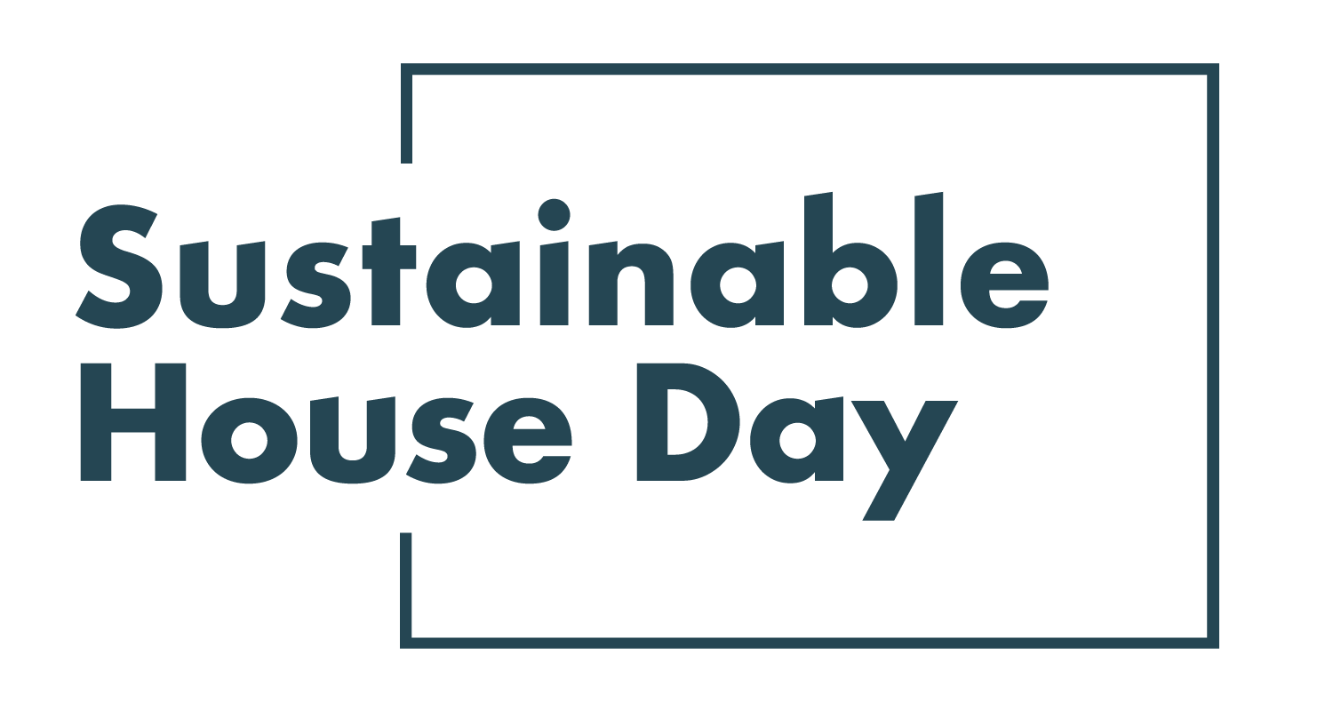
Media Release [date]
—
XXX Hosting Event as part of Sustainable House Day
—
XXX is hosting a community partner event as part of the national Sustainable House Day program.
Established in 2001, Sustainable House Day is a national event that facilitates peer-to-peer knowledge sharing on sustainable building, design and living by providing access to Australia’s most unique sustainable homes.
This year, Sustainable House Day into a month-long event, featuring four themed weeks of webinars with experts and homeowners as well as a program of free online events on October 17. In addition, community partners around the country will be hosting their own in person and online events during this period.
With these events, Sustainable House Day will provide countless opportunities for education and inspiration for those looking to reduce their homes’ environmental impact.
Our ACT offerings this year include the light and airy renovation Little Loft House, designed by local sustainable hero Jenny Edwards of Light House Architecture and Science, which used smart design to raise the home’s energy efficiency rating from 3.8 to 7.7. Another fantastic example of clever and well-considered design is Backyard Retirement, a secondary dwelling built with ageing in place and accessibility in mind. With ideal orientation and thoughtful use of materials, the home achieved an 8.0 rating from the Nationwide House Energy Rating Scheme (NatHERS).
Sustainable House Day is organised by Renew, a national, not-for-profit organisation that inspires, enables and advocates for people to live sustainably in their homes and communities.
—
Bookings for our entire program are open on our website, sustainablehouseday.com
National Sustainable House Day media contact: Diane Falzon, pr@dianefalzon.com, 0430 596 699
Little Loft House contact: Jenny Edwards, jenny@lighthouseteam.com.au, 0424 635 082

Backyard Retirement contact: Jen Wetselaar, jennifer.wetselaar@gmail.com, 0408 233 910

