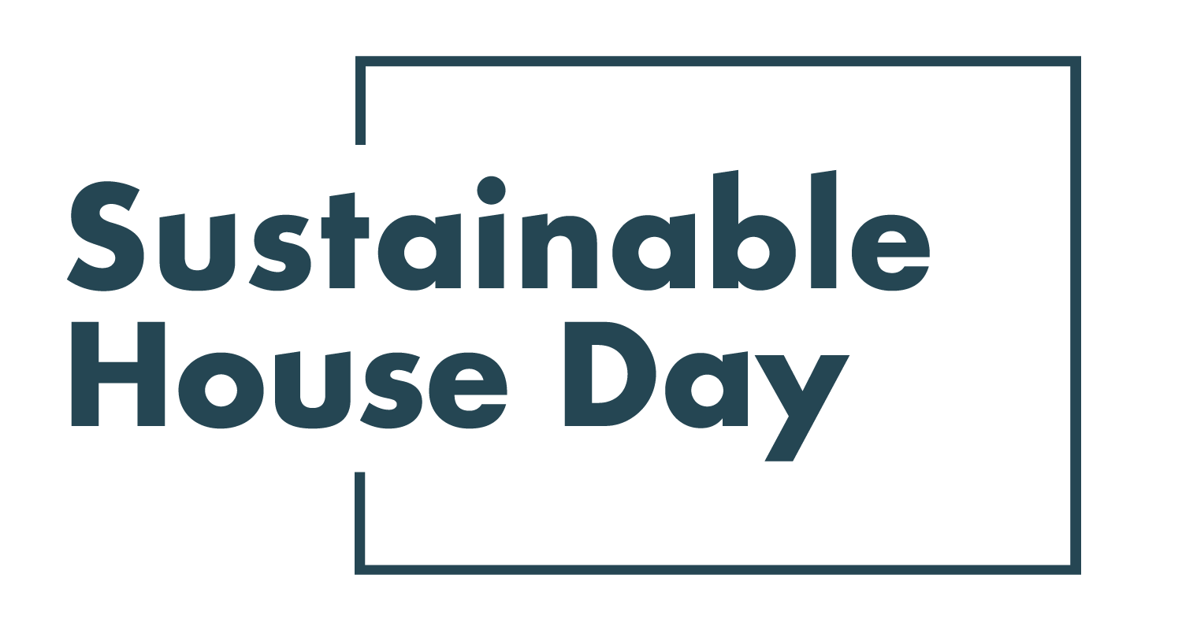

Press Release - 8 September 2021
—
27 homes across NSW featured nationally as part of Sustainable House Day 2021
—
New South Wales’ most sustainable homes will be on show online as part of Sustainable House Day 2021.
Established in 2001, Sustainable House Day is a national event that facilitates peer-to-peer knowledge sharing on sustainable building, design and living by providing access to Australia’s most unique sustainable homes.
This year, we’ve expanded Sustainable House Day into a month-long event, featuring four themed weeks of webinars with experts and homeowners as well as a program of free online events on October 17. In addition, community partners around the country will be hosting their own in person and online events during this period.
With these events, Sustainable House Day will provide countless opportunities for education and inspiration for those looking to reduce their homes’ environmental impact.
Homes featured in NSW this year include One Tree Hill, a modest but beautiful and highly effective home built deep in the Southern Tablelands, near Canberra. The home provides all of its own power and most of its water through solar panels and rainwater collection. Its orientation, shading and concrete slab allows the home to stay cool in the summer and warm in the winter, without active heating or cooling. For a more urban perspective, we’re also showcasing PassivCourtyard in Sydney’s Inner West. Designed by local sustainable experts Envirotecture, the home is a certified Passive House, meaning it is nearly airtight and highly insulated, to keep temperature stable year-round. PassivCourtyard also includes a green roof to further insulate the home.
— END —
Sustainable House Day is organised by Renew, a national, not-for-profit organisation that inspires, enables and advocates for people to live sustainably in their homes and communities.
—
Bookings for our entire program are open on our website, sustainablehouseday.com
National Sustainable House Day media contact: Diane Falzon, pr@dianefalzon.com, 0430 596 699
One Tree Hill homeowner contact: Sarah Leheny, shags22@gmail.com, 0410 476 392
PassivCourtyard designer contact: Dick Clarke, info@envirotecture.com.au, 0403 003 997

