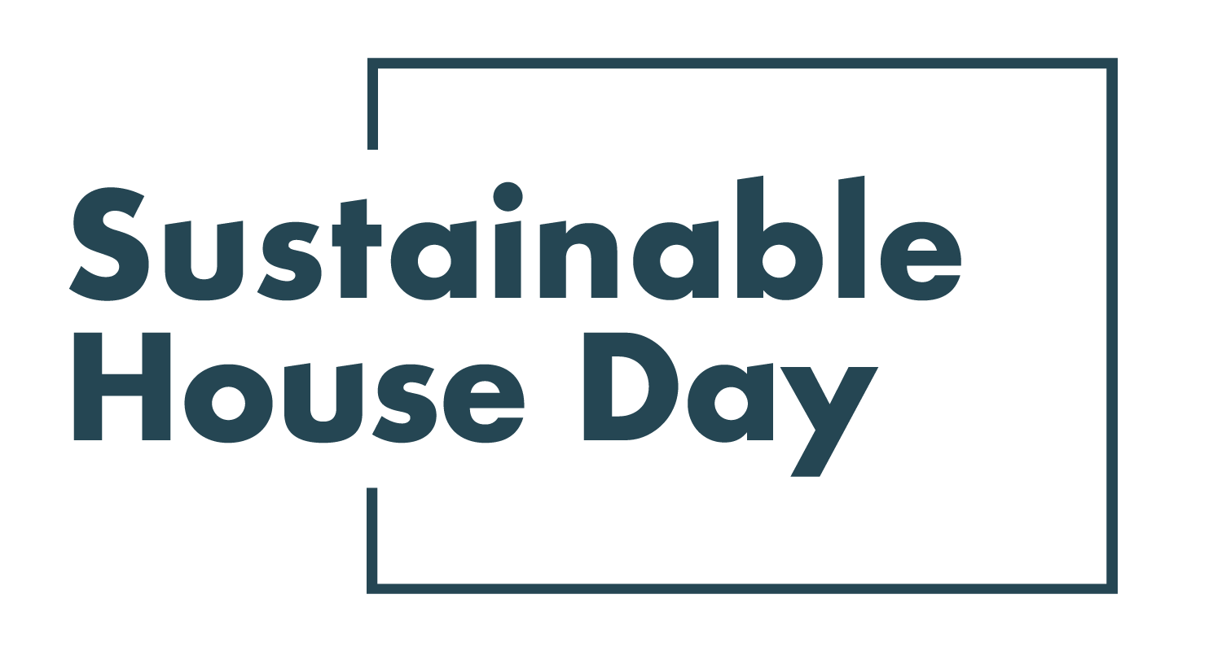

Press Release - 8 September 2021
—
15 QLD homes featured nationally as part of Sustainable House Day 2021
—
Queensland’s most sustainable homes will be on show online as part of Sustainable House Day 2021.
Established in 2001, Sustainable House Day is a national event that facilitates peer-to-peer knowledge sharing on sustainable building, design and living by providing access to Australia’s most unique sustainable homes.
This year, we’ve expanded Sustainable House Day into a month-long event, featuring four themed weeks of webinars with experts and homeowners as well as a program of free online events on October 17. In addition, community partners around the country will be hosting their own in person and online events during this period.
With these events, Sustainable House Day will provide countless opportunities for education and inspiration for those looking to reduce their homes’ environmental impact.
Houses participating in QLD this year include Treehouse Extension in Brisbane’s Carina Heights allowed a couple to create more space for their family with an airy but modest two-story extension, without impacting their 1940s home. Thanks to the extension’s clever design, it doesn’t need air conditioning, relying on cross ventilation, and connects to the beautiful established garden. For a fantastic example of sustainable design in difficult climates, check out Tropical Pavilions in Cairns, designed by Tony Lawson. Built within a lush tropical garden, the house is designed as a series of pods to allow for flexible use and was designed with resilience against cyclones in mind. Lawson’s design makes it possible to live without air conditioning in one of Australia’s most difficult climate zones.
— END —
Sustainable House Day is organised by Renew, a national, not-for-profit organisation that inspires, enables and advocates for people to live sustainably in their homes and communities.
—
Bookings for our entire program are open on our website, sustainablehouseday.com
National Sustainable House Day media contact: Diane Falzon, pr@dianefalzon.com, 0430 596 699
Treehouse Extension designer contact: Emma Scragg, mail@emmascragg.com, 0404 870 744
Tropical Pavilions designer contact: Tony Lawson, tony@lawsondesign.com.au, 0412 592 900

