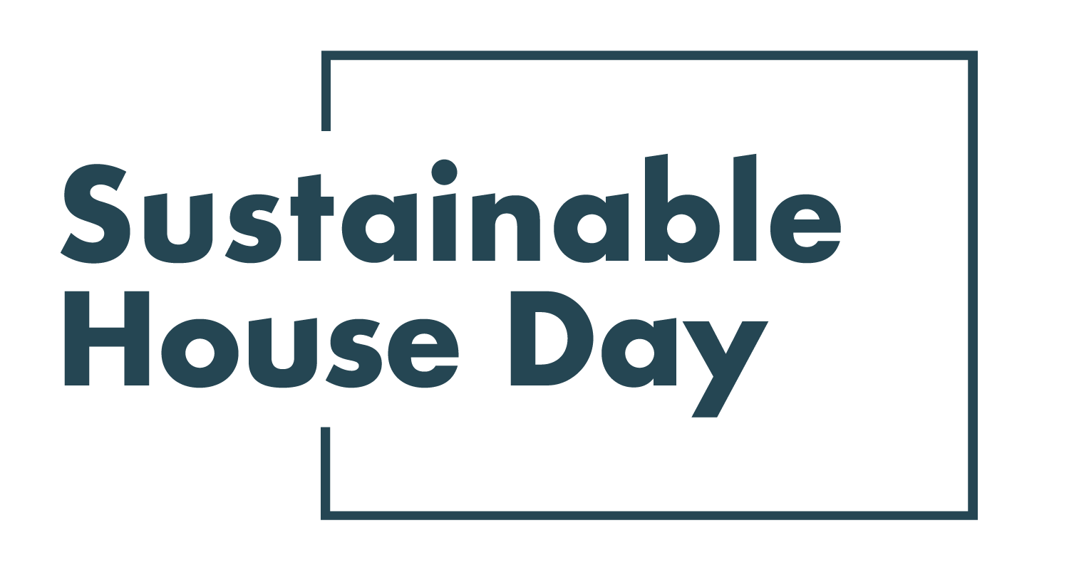

Press Release - 8 September 2021
—
12 South Australian homes featured nationally as part of Sustainable House Day 2021
—
South Australia’s most sustainable homes will be on show online as part of Sustainable House Day 2021.
Established in 2001, Sustainable House Day is a national event that facilitates peer-to-peer knowledge sharing on sustainable building, design and living by providing access to Australia’s most unique sustainable homes.
This year, we’ve expanded Sustainable House Day into a month-long event, featuring four themed weeks of webinars with experts and homeowners as well as a program of free online events on October 17. In addition, community partners around the country will be hosting their own in person and online events during this period.
With these events, Sustainable House Day will provide countless opportunities for education and inspiration for those looking to reduce their homes’ environmental impact.
Our SA offerings this year include Sunny Eco Home in Mount Barker, a thermally efficient home that requires little active heating or cooling also features rainwater collection tanks and an extensive garden. The homeowners built this sanctuary after their previous home was burned down in a bushfire. Another gem in this year’s event is Earthship Inman Valley, a unique home located south of Adelaide. Earthships are a passive solar building style invented by American architect Michael Reynolds in the 1970s that emphasise use of recycled materials like tyres and bottles, earth walls to create thermal mass and permaculture gardens to supply food. This example shows how powerful the model can be: the house is totally self-sufficient as far as energy, water and sewage. The home includes a “greenhouse” facing north that brings winter light into the home and “earthtubes” help keep the house cool in summer.

— END —
Sustainable House Day is organised by Renew, a national, not-for-profit organisation that inspires, enables and advocates for people to live sustainably in their homes and communities.
—
Bookings for our entire program are open on our website, sustainablehouseday.com
National Sustainable House Day media contact: Diane Falzon, pr@dianefalzon.com, 0430 596 699
Sunny Eco Home homeowner contact: Cathy Sarles, Cathy.sarles@gmail.com
Earthship Inman Valley homeowner contact: Evie Verdini Fensom, evie.vf@live.com.au

