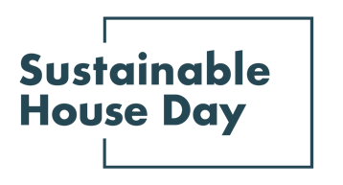

Press Release - 8 September 2021
—
Tassie’s most sustainable homes featured as part of Sustainable House Day 2021
—
Five of Tasmania’s most sustainable homes will be on show online as part of Sustainable House Day 2021.
Established in 2001, Sustainable House Day is a national event that facilitates peer-to-peer knowledge sharing on sustainable building, design and living by providing access to Australia’s most unique sustainable homes.
This year, we’ve expanded Sustainable House Day into a month-long event, featuring four themed weeks of webinars with experts and homeowners as well as a program of free online events on October 17. In addition, community partners around the country will be hosting their own in person and online events during this period.
With these events, Sustainable House Day will provide countless opportunities for education and inspiration for those looking to reduce their homes’ environmental impact.
Our TAS offerings this year include Thinking Paddock House, located in a gorgeous location on the water in Sandford. Even when buffeted by winds in the cold Tassie winter, the home maintains high thermal performance, helped by thick insulation and double-glazed windows. With an 8kw solar system, the owners have never had to pay a power bill. Another fantastic example of our open homes is Lake Tahune Hut, designed by Green Design Architects. This mountain hut in Franklin Gordon Wild Rivers National Park was designed with high levels of insulation to protect against the frequently freezing temperatures, and is fully off-grid, using only a small amount of energy provided by a micro-hydro power supply from a nearby creek.
As part of Sustainable House Day local design studio Designful will be hosting an in person event in Hobart on 14 October with a panel discussion on sharing land and building sustainable communities.
— END —
Sustainable House Day is organised by Renew, a national, not-for-profit organisation that inspires, enables and advocates for people to live sustainably in their homes and communities.
—
Bookings for our entire program are open on our website, sustainablehouseday.com
National Sustainable House Day media contact: Diane Falzon, pr@dianefalzon.com, 0430 596 699
Lake Tahune Hut architect contact: Uta Green, GreenDesignArchitects@mail.com, 362246810
Thinking Paddock House architect contact: Daniel Moore, daniel@opencreativestudio.com, 0418 363 839

