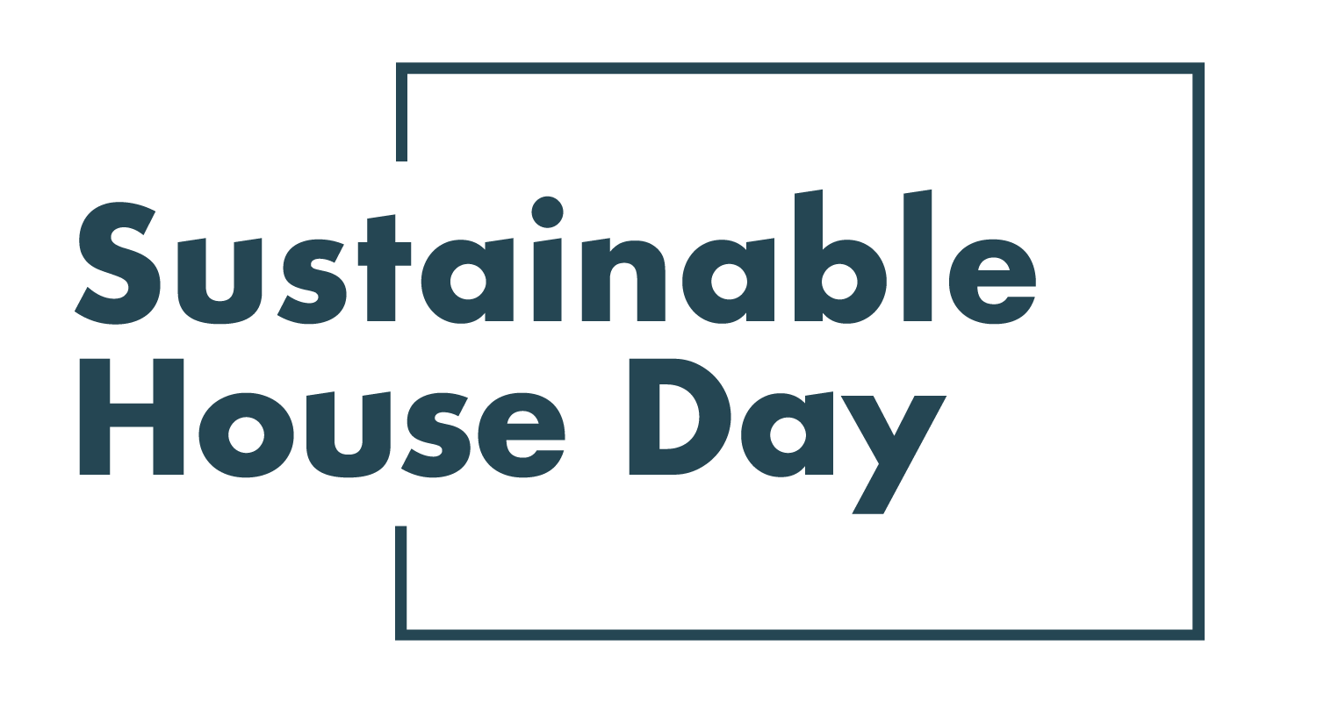

Press Release - 8 September 2021
—
34 Victorian homes featured nationally as part of Sustainable House Day 2021
—
Victoria’s most sustainable homes will be on show online as part of Sustainable House Day 2021.
Established in 2001, Sustainable House Day is a national event that facilitates peer-to-peer knowledge sharing on sustainable building, design and living by providing access to Australia’s most unique sustainable homes.
This year, we’ve expanded Sustainable House Day into a month-long event, featuring four themed weeks of webinars with experts and homeowners as well as a program of free online events on October 17. In addition, community partners around the country will be hosting their own in person and online events during this period.
With these events, Sustainable House Day will provide countless opportunities for education and inspiration for those looking to reduce their homes’ environmental impact.
House participating in Victoria this year include Green Home Build, a house in Melbourne’s eastern suburbs that takes sustainability to the next level. The beautiful timber-clad home was constructed using solar power, a new frontier of renewable energy use. It boasts a 8.4 NatHERS rating, and was constructed in part from materials recovered from a deconstructed home on the same site, minimizing waste. Another highlight is Iris House in Camperdown. Iris House is proof that sustainable homes can be built on a budget: its owner is a single mother who altered a standard prefabricated home to achieve a highly energy efficient and comfortable dwelling for just over $200,000.

— END —

Sustainable House Day is organised by Renew, a national, not-for-profit organisation that inspires, enables and advocates for people to live sustainably in their homes and communities.
—
Bookings for our entire program are open on our website, sustainablehouseday.com
National Sustainable House Day media contact: Diane Falzon, pr@dianefalzon.com, 0430 596 699
Green Home Build homeowner contact: Howard Elston, howard.elston@gmail.com, 0407 785 321
Iris House homeowner contact: Sophie MacRae, sophiamacrae@gmail.com, 0411 755 677

