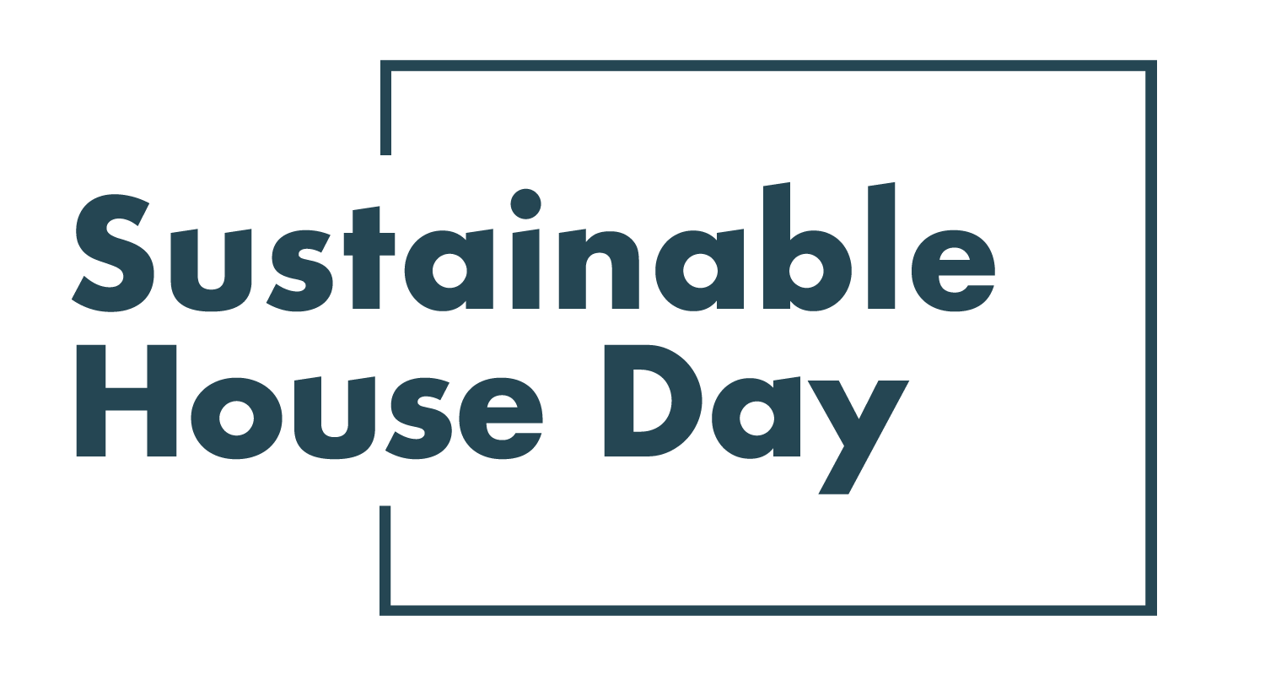

Press Release - 8 September 2021
—
29 homes across Western Australia featured nationally as part of Sustainable House Day 2021
—
Western Australia’s most sustainable homes will be on show online as part of Sustainable House Day 2021.
Established in 2001, Sustainable House Day is a national event that facilitates peer-to-peer knowledge sharing on sustainable building, design and living by providing access to Australia’s most unique sustainable homes.
This year, we’ve expanded Sustainable House Day into a month-long event, featuring four themed weeks of webinars with experts and homeowners as well as a program of free online events on October 17. In addition, community partners around the country will be hosting their own in person and online events during this period.
With these events, Sustainable House Day will provide countless opportunities for education and inspiration for those looking to reduce their homes’ environmental impact.
Participating homes across Western Australia this year include WA’s First Passive House Plus, a home that uses sustainable technology to achieve a high level of efficiency and temperature stability. Located in Perth’s northern suburbs, this home is certified under the Passive House Plus standard, meaning it was built to be nearly airtight and with insulation that reduced the need for active heating and cooling. Another inspiring home is Djildjit, in White Gum Valley, a home that shows that urban density can coexist with sustainability. This passive solar apartment is connected to another identical apartment, and both are constructed from rammed earth.
In addition to our online events, the Renew Perth Members’ Branch will be hosting several in person events along with local sustainable designers Solar Dwellings throughout the month of Sustainable House Day, including talks on site selection and passive solar design.
— END —
Sustainable House Day is organised by Renew, a national, not-for-profit organisation that inspires, enables and advocates for people to live sustainably in their homes and communities.
—
Bookings for our entire program are open on our website, sustainablehouseday.com
National Sustainable House Day media contact: Diane Falzon, pr@dianefalzon.com, 0430 596 699
WA’s First Passive House Plus homeowner contact: Carlos Acuna, carlos.acuna23@yahoo.com, 0467 637 182
Djildjit homeowner contact: Martin Anda, m.anda@murdoch.edu.au, 0433 707 196

