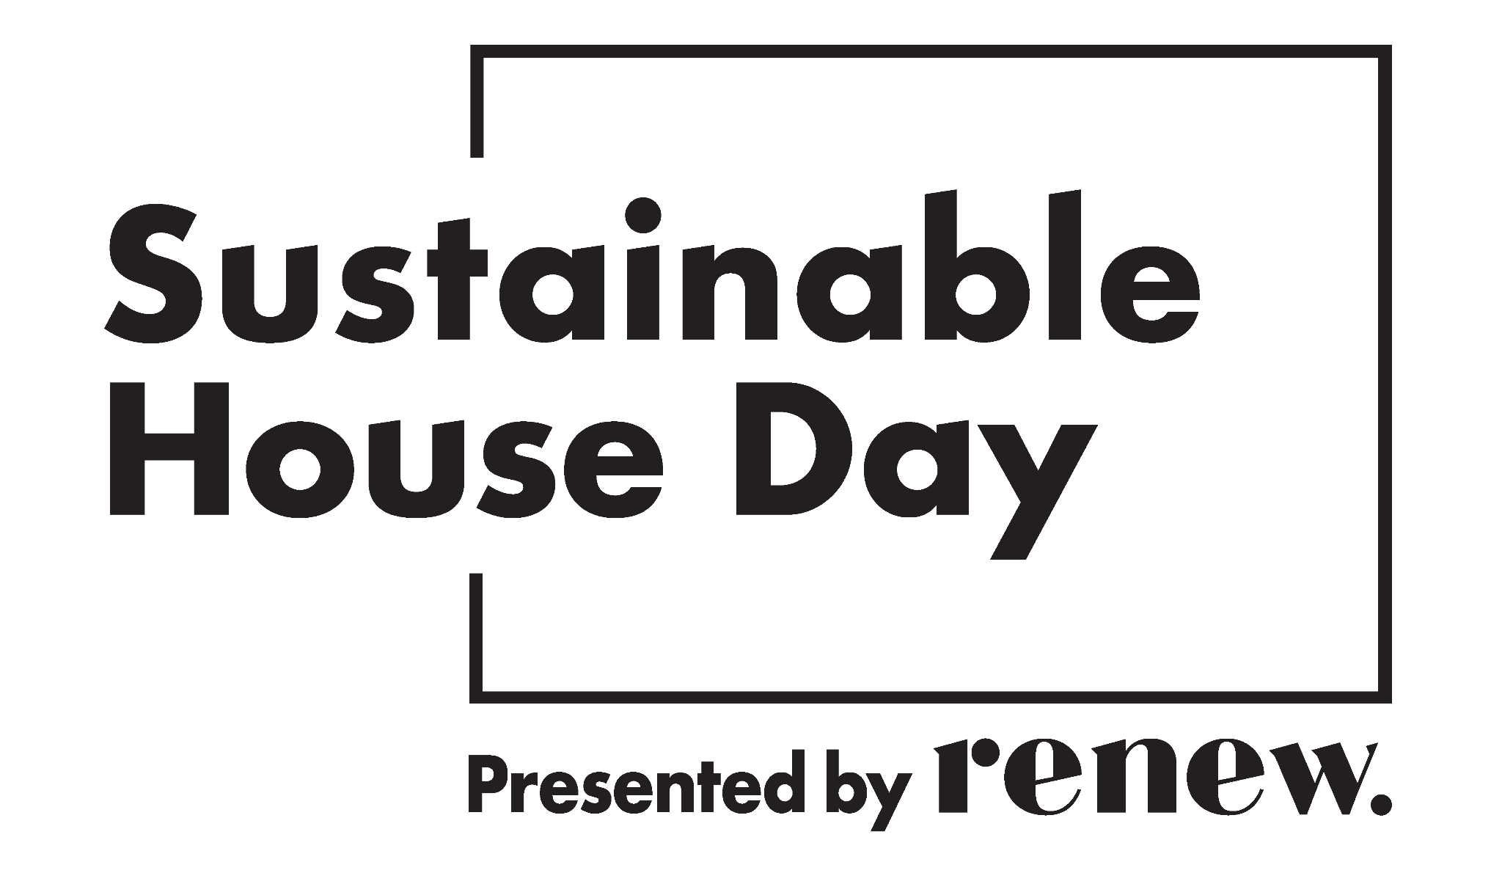
House Tour Talking Points
Thank you for opening your home for Sustainable House Day 2025.
This document is a template designed to help you share the story of your home and its energy-efficiency and sustainability features. Use it as a guide and take what you need from it.

Planning
Walk around your property and jot down all the energy-efficiency and sustainability features. Use the “House features” list at page 6 onwards or refer to your house profile on the SHD website or the email of the application you submitted – you probably already have most of the information you need.
Identify 3 to 5 places around your property with clusters of key features and with space to allow ALL people in the tour to be able to see and hear about what is being highlighted. These will be the “point-of-interest” stops for your tour.
Reorganise your list of features into talking points that you will discuss at each point-of-interest stop. You probably won’t have time to talk about everything so prioritise the features that are most meaningful to you. You could stick notes on features you decide not to talk about.
Practice your tour and talking points: aim to take around 45-50 minutes total, including time at each point-of-interest for questions and to move the group to the next point. Allow another 10-15 minutes at the end for further discussion.
Some attendees will ask for data and details. If you have specifications for products or data about energy production/consumption, energy efficiency ratings, etc, consider noting these details in your talking points or printing graphs or screenshots or having before-and-after energy bills handy, house plans on display, etc. You could write a one-page summary of your home’s features and have printed copies for attendees to take away, or refer them to your home’s online profile.
Yes, you can mention and can (but are not expected to) have promotional materials from specific products, brands, services, installers, local businesses etc, but please emphasise that these were your personal choices, and are not recommendations or endorsements from Renew.
Plan what you will do in the event of wet weather, e.g. move everyone indoors or keep everyone outdoors, provide umbrellas or have a spot for wet umbrellas and coats, ask people to remove muddy shoes (this will take extra time) or lay towels or mats on the floor.

Conducting the tour
- Guide attendees to your first point-of-interest space
- Wait until everyone is in the space – have one of your team bring up the rear to keep everyone together
- Keep your talking points short and stick to them so you cover everything you planned but don’t talk for too long
- Take questions for a few minutes
- Move to the next point-of-interest space and repeat.
Keep an eye on the time – Tour should be complete within 1 hour.

Point-of-interest 1: Housekeeping and Introduction
- Welcome visitors to your home and introduce yourself to the group.
- Read an Acknowledgement of Country.
“We acknowledge First Nations people as the traditional custodians of these lands, their continuing connection to land and culture, and their contribution to society. We pay our respect to Elders past and present and acknowledge that Sovereignty was never ceded.”
- Tell visitors briefly how the tour will proceed, e.g. intro here, 2 stops inside, 1 stop in the garden, finish in the garage.
- Show the emergency response meeting area.
- Give any instructions about shoes or bags or bathrooms or photography or privacy, etc.
- Ask people to not separate from the group and always remain in sight of your tour guide.
- Give any safety instructions e.g. watch your step at (location), if applicable.
- Play the presentation video provided by Renew at the first location with a television screen. If you do not have the ability to play the video, please read the script provided by Renew.
Briefly tell your home’s story:
  - your home’s history,
  - key energy & sustainability choices or changes you have made,
  - your motivation for doing so,
  - what value they have added to your lifestyle or budget.
Point out key sustainability features you can see at this location

Ask if visitors have questions
Mention any sustainability features or safety hazards to look out for while moving to the next point-of-interest

Point-of-interest 2
Point out key sustainability features you can see at this location

Ask if visitors have questions
Mention any sustainability features or safety hazards to look out for while moving to the next point-of-interest

Point-of-interest 3
Point out key sustainability features you can see at this location

Ask if visitors have questions
Mention any sustainability features or safety hazards to look out for while moving to the next point-of-interest

Point-of-interest 4
Point out key sustainability features you can see at this location.

Ask if visitors have questions.
Mention any sustainability features or safety hazards to look out for while moving to the next point-of-interest.

Point-of-interest 5
Point out key sustainability features you can see at this location.

Ask if visitors have questions.
Mention any sustainability features or safety hazards to look out for while moving to the next point-of-interest.

End of tour
- Thank the visitors for coming. If they have further questions, they can ask them on your house profile on the Sustainable House Day website sustainablehouseday.com
- Tell visitors to visit the SHD website to book tickets for the webinar series and find local community events through May – details are in the A5 booklets that Renew sent you to distribute to visitors.
- Ask them to fill in the survey that Renew will email to everyone.
- Check for any issues / injuries – record details.
- Ask them to make sure they have all their belongings.
- Point out the exit and ask visitors to leave promptly so you can prepare for the next tour.

House features
The following are prompts to help you identify the features of your home, prepare your talking points and answer visitor questions. They may not all be relevant, and don’t worry if you don’t know all the answers.

Building history
Originally built in (year)
Major renovations / extensions / refits

Construction methods & materials
Particular method / standard / certification
Roof
Walls
Floor
Reused / recycled materials

Compass/solar orientation
Thermal mass

Doors & Windows
Types / glazing / frames
Window coverings (internal)
Window protection / shading (external)

Insulation
Envelope
Ceiling
Walls
Floor
Draught sealing
Ventilation
Energy efficiency rating (EER)

Energy
Solar power (size of system)
Battery (capacity)
Gas (phasing out)
Water heating
Monitoring

Heating and cooling
Passive methods
Active (powered) appliances

Lighting
Natural
Installed light types

Appliance types & energy/water efficiency
Kitchen: cooking / washing / fridge
Laundry: washing / drying / grey water
Bathroom: toilets / shower heads / water-saving

Electric vehicle
Car(s) / bike(s)
Charging facility

Water management
Rainwater collection / storage / usage
Stormwater management
Grey water usage
Garden irrigation

Garden / landscaping
Plant choices eg shade vs sun
Edible plants
Biodiversity
Accessibility
Composting
Climate resilience
Permeable surfaces

Waste reduction / circular economy / sustainable lifestyle choices
Reuse / swap / borrow / trade / donate: eg
Repair / maintain / refurbish: eg
Recycle: eg
Eco-friendly products: eg

