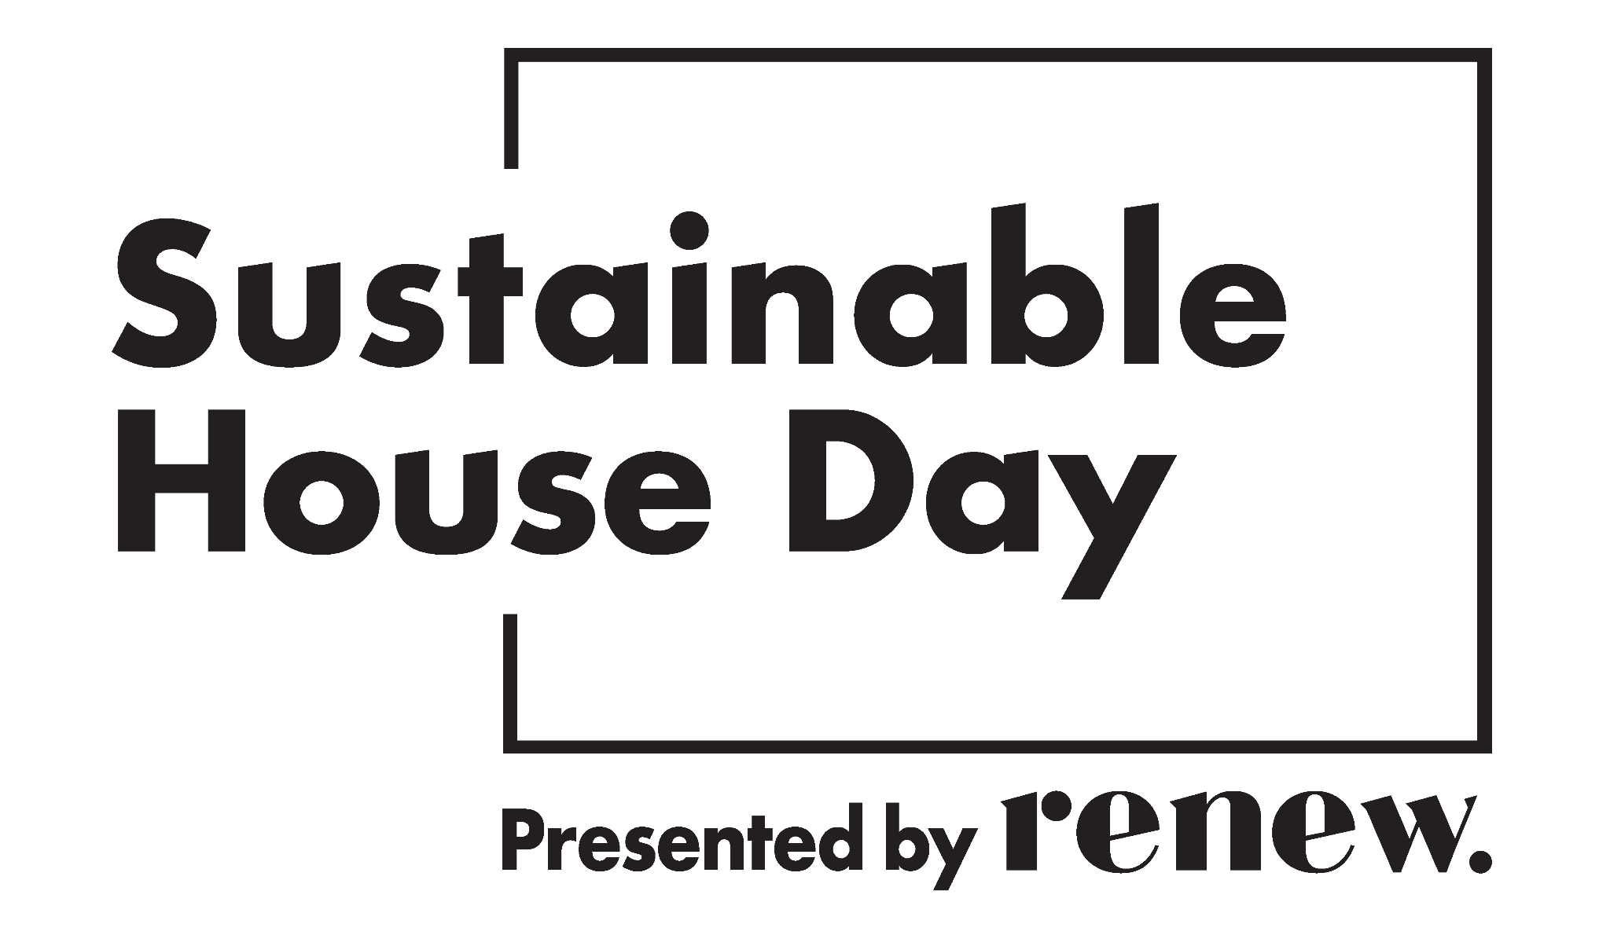

Dear Neighbour
We are writing to let you know that our home will be open for public tours for Sustainable House Day on Sunday 4 May 2025.
This means we expect to welcome groups of visitors during the day who have purchased tickets to attend tours and who will be likely to park their cars in our street. If you are able to make parking space available out the front of your house, that would be greatly appreciated.
In case you are interested, our home is listed on the Sustainable House Day website as
……………………………………………………………………………..………[Title of house profile]
We apologise in advance for any inconvenience caused.
Warm regards,

Renew’s Sustainable House Day program, May 2025
Sustainable House Day, hosted by Renew, is an annual, national event offering the opportunity to explore some of Australia’s most inspiring green homes, and learn from the people who designed them, built them and live in them.
If you are thinking about building, renovating or retrofitting to make your home more energy-efficient and comfortable, the Sustainable House Day program offers many ways to learn from experts across the country, local community groups, and homeowners in your neighbourhood.
Open house tours: on Sunday 4 May, 150 homes across Australia will open their doors and share their experience of building, retro-fitting and living in sustainable homes – Find featured houses near you and book via their individual ticket links. Visit in person to receive exclusive SHD discounts!
Live expert webinar series: Tuesdays & Thursdays in May – Buy individual session tickets or save by buying a Series Pass. Get 50% off the price of the Series Pass if you live in a Partner Council area.
Community partner events: throughout May – independent events in-person and online around the country. Follow the “Book now” links to register or purchase tickets.
Explore the full program at sustainablehouseday.com

